CO-3 : ASSESSMENT TOOL – 1
CASE STUDY

NAME : B. TARUNREDDY
REG.NO : 192424213
COURSE CODE : DSA0404
COURSE NAME : FUNDAMENTALS OF DATA SCIENCE
FACULTY NAME : DR. KRISHNARAJ MONY

CASE STUDY 1 – EMPLOYEE SALARIES
PROBLEM IDENTIFICATION AND ANALYSIS
A company records the annual salaries (in ₹ lakhs) of 9 employees as follows:
4, 5, 5, 6, 7, 8, 8, 9, 30
Using the above data,
- Find the Mean.
- Find the Median.
- Find the Mode.
- Find the Range.
- Calculate the Population Variance.
- Calculate the Population Standard Deviation.
- Identify the Outlier.
- Explain which measure of central tendency best represents the typical salary.
Given Data
Employee | Salary (₹ Lakhs)
1 | 4
2 | 5
3 | 5
4 | 6
5 | 7
6 | 8
7 | 8
8 | 9
9 | 30
Number of observations : n = 9Theory
Mean
The mean is the average value of all observations.
It is calculated by dividing the total of all values by the number of observations.
Median
The median is the middle value after arranging the data in ascending order.
Mode
The mode is the value that occurs most frequently.
Range
The range is the difference between the maximum and minimum values.
Population Variance:Variance measures how far the values are spread from the mean.

Step 1 – Data
Employee salaries (in lakhs):
4, 5, 5, 6, 7, 8, 8, 9, 30

Step 2 – Mean
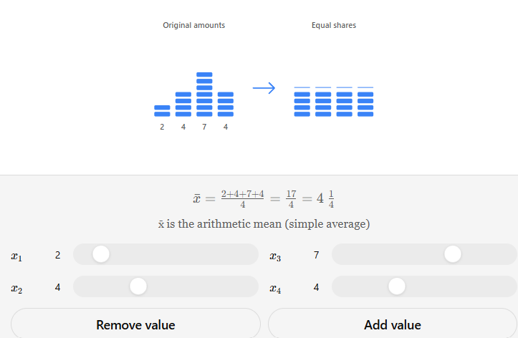
Formula:
Mean = Sum of Salaries ÷ Number of Employees
= 82 ÷ 9
= ₹9.11 Lakhs
Interpretation: The average salary is ₹9.11 lakhs, but it is increased by the unusually high salary of ₹30 lakhs.
Step 3 – Median
Number of observations = 9
Median Position = (9 + 1) ÷ 2 = 5th observation
Median = ₹7 Lakhs
Interpretation: The median represents the middle salary and is not affected by the outlier.
Step 4 – Mode
Salary frequencies:
- ₹5 Lakhs – 2 times
- ₹8 Lakhs – 2 times
Mode = ₹5 Lakhs and ₹8 Lakhs (Bimodal)

Step 5 – Range
Range = Highest Salary − Lowest Salary
= 30 − 4
= ₹26 Lakhs
Step 6 – Population Variance
Mean = 9.11
Sum of squared deviations = 512.91
Variance = 512.91 ÷ 9
= 56.99
Interpretation: The high variance is caused by the ₹30 lakh salary.
Step 7 – Population Standard Deviation
Standard Deviation = √56.99
= ₹7.55 Lakhs
This shows that salaries vary by about ₹7.55 lakhs from the average.
Step 8 – Outlier
Outlier: ₹30 Lakhs
Effect:
- Increases the Mean
- Increases the Variance
- Increases the Standard Deviation
- Has little effect on the Median and Mode
Step 9 – Best Measure of Central Tendency
Best Measure: Median (₹7 Lakhs)
Reason: The ₹30 lakh salary is an outlier that raises the mean. Since most employees earn between ₹4 lakhs and ₹9 lakhs, the median better represents the typical employee salary.

Final Results
Measure | Result
Mean | ₹9.11 Lakhs
Median | ₹7 Lakhs
Mode | ₹5 Lakhs and ₹8 Lakhs
Range | ₹26 Lakhs
Population Variance | 56.99
Population Standard Deviation | ₹7.55 Lakhs
Outlier | ₹30 Lakhs
Best Measure | Median

CASE STUDY 2 – WEBSITE RESPONSE TIME

Problem Statement
A data scientist records the response time (in milliseconds) of a website for 10 requests.
The response times are:
120, 125, 128, 130, 132, 135, 140, 145, 150, 300
Using the above data,
- Calculate the Mean.
- Calculate the Median.
- Find the Range.
- Calculate the Population Variance.
- Calculate the Population Standard Deviation.
- Determine whether the data is right-skewed or left-skewed.
- Explain why the Median is more useful than the Mean.
Given Data
Request | Response Time (ms)
1 | 120
2 | 125
3 | 128
4 | 130
5 | 132
6 | 135
7 | 140
8 | 145
9 | 150
10 | 300
Number of observations
n = 10
Theory
Mean
The mean is the average response time.
It is obtained by dividing the sum of all response times by the total number of observations.
Median
The median is the middle value after arranging the observations in ascending order.
For an even number of observations,
Median = Average of the two middle values.
Range
The range shows the difference between the highest and lowest response times.
Population Variance
Variance measures how much the response times differ from the average response time.
Population Standard Deviation
Standard deviation is the square root of the variance. It measures the average spread of the response times around the mean.

Step 1 – Data
Website response times (in milliseconds):
120, 125, 128, 130, 132, 135, 140, 145, 150, 300

Step 2 – Mean
Formula:
Mean = Sum of Response Times ÷ Number of Observations
= 1505 ÷ 10
= 150.5 ms
Interpretation: The average response time is 150.5 ms, but it is increased by the unusually high response time of 300 ms.

Step 3 – Median
There are 10 observations, so the median is the average of the 5th and 6th values.
Median = (132 + 135) ÷ 2
= 133.5 ms
Interpretation: The median represents the typical response time and is not affected by the outlier.

Step 4 – Range
Range = Highest Response Time − Lowest Response Time
= 300 − 120
= 180 ms

Step 5 – Population Variance
Mean = 150.5 ms
Sum of squared deviations = 25581.50
Variance = 25581.50 ÷ 10
= 2558.15 ms²
Interpretation: The high variance is mainly caused by the 300 ms response time.

Step 6 – Population Standard Deviation
Standard Deviation = √2558.15
≈ 50.58 ms
This indicates that response times vary by about 50.58 ms from the average.

Step 7 – Skewness
Skewness: Right-Skewed (Positively Skewed)
Reason: Most response times are between 120 ms and 150 ms, while 300 ms creates a long right tail and increases the mean.

Step 8 – Best Measure of Central Tendency
Best Measure: Median (133.5 ms)
Reason: The 300 ms response time is an outlier that raises the mean. The median better represents the normal website response time because it is not influenced by extreme values.

Final Results
Measure | Result
Mean | 150.5 ms
Median | 133.5 ms
Range | 180 ms
Population Variance | 2558.15 ms²
Population Standard Deviation | 50.58 ms
Skewness | Right-Skewed (Positively Skewed)
Best Measure | Median

CASE STUDY 3 – STUDENT PERFORMANCE ANALYSIS

Problem Statement
The marks of 12 students in a Data Science test are:
42, 45, 48, 50, 52, 52, 55, 58, 60, 62, 65, 95
Using the above data,
- Find Q1, Q2, and Q3.
- Calculate the Interquartile Range (IQR).
- Use the 1.5 × IQR rule to identify any outliers.
- Calculate the Mean.
- Calculate the Median.
- Explain how the outlier affects the Mean.

Given Data
Student | Marks
1 | 42
2 | 45
3 | 48
4 | 50
5 | 52
6 | 52
7 | 55
8 | 58
9 | 60
10 | 62
11 | 65
12 | 95
Number of observations:
n = 12
Theory
Quartiles
Quartiles divide the data into four equal parts.
- Q1 (First Quartile): 25% of observations lie below Q1.
- Q2 (Second Quartile): Median of the dataset.
- Q3 (Third Quartile): 75% of observations lie below Q3.
Interquartile Range (IQR)
The Interquartile Range measures the spread of the middle 50% of the data.
Formula
IQR = Q3 − Q1
Outlier
An outlier is an observation that is much smaller or larger than the other observations.
Outliers are identified using:
Lower Limit = Q1 − 1.5 × IQR
Upper Limit = Q3 + 1.5 × IQR
Any value outside these limits is an outlier.

Step 1 – Data
Student marks (ascending order):
42, 45, 48, 50, 52, 52, 55, 58, 60, 62, 65, 95
Step 2 – Quartiles
There are 12 observations.
- Q2 (Median) = (52 + 55) ÷ 2 = 53.5
- Q1 = (48 + 50) ÷ 2 = 49
- Q3 = (60 + 62) ÷ 2 = 61
Step 3 – Interquartile Range (IQR)
Formula:
IQR = Q3 − Q1
= 61 − 49
= 12
Step 4 – Outlier Detection
Lower Limit = Q1 − 1.5(IQR)
= 49 − 18 = 31
Upper Limit = Q3 + 1.5(IQR)
= 61 + 18 = 79
Any value below 31 or above 79 is an outlier.
Outlier = 95
Step 5 – Mean
Mean = Sum of Marks ÷ Number of Students
= 684 ÷ 12
= 57
Step 6 – Median
Already calculated:
Median = 53.5
Since the mean (57) is higher than the median (53.5), the high score of 95 increases the average.

Interpretation
The middle 50% of students scored between 49 and 61 marks (IQR = 12), indicating a moderate spread. The score of 95 is an outlier that raises the mean but has little effect on the median. Therefore, the median better represents the typical student performance.
Final Results
Measure | Result
Q1 | 49
Q2 (Median) | 53.5
Q3 | 61
IQR | 12
Lower Limit | 31
Upper Limit | 79
Outlier | 95
Mean | 57
Median | 53.5

CASE STUDY 4 – E-COMMERCE ORDERS
Problem Statement
An online store records the number of orders received over 10 days as follows:
18, 20, 22, 22, 24, 25, 26, 28, 30, 35
Using the above data,
- Calculate the Mean.
- Calculate the Median.
- Find the Mode.
- Calculate the Population Variance.
- Calculate the Population Standard Deviation.
- Calculate the Coefficient of Variation (CV).
- Explain what the Standard Deviation tells the company.
- Determine whether the order data is highly or moderately variable.

Given Data:
Day | Number of Orders
1 | 18
2 | 20
3 | 22
4 | 22
5 | 24
6 | 25
7 | 26
8 | 28
9 | 30
10 | 35
Number of observations:
n = 10
Theory
Mean
The mean is the average number of orders received per day.
Median
The median is the middle value after arranging the data in ascending order.
Mode
The mode is the value that appears most frequently.
Population Variance
Variance measures how widely the daily order counts are spread around the mean.
Population Standard Deviation
Standard deviation indicates the average distance of each day's orders from the mean.
Coefficient of Variation (CV)
The coefficient of variation compares the standard deviation with the mean and expresses variability as a percentage.
Formula
CV = (Standard Deviation ÷ Mean) × 100%

Step 1 – Data
Daily customer orders (ascending order):
18, 20, 22, 22, 24, 25, 26, 28, 30, 35
Step 2 – Mean
Formula:
Mean = Sum of Orders ÷ Number of Days
= 250 ÷ 10
= 25 Orders
Interpretation: On average, the company receives 25 customer orders per day.
Step 3 – Median
There are 10 observations.
Median = (24 + 25) ÷ 2
= 24.5 Orders
Step 4 – Mode
The value 22 occurs twice, while all other values occur once.
Mode = 22 Orders
Step 5 – Population Variance
Mean = 25
Sum of squared deviations = 228
Variance = 228 ÷ 10
= 22.8
Step 6 – Population Standard Deviation
Standard Deviation = √22.8
≈ 4.77 Orders
This indicates that daily orders vary by about 4.77 orders from the average.
Step 7 – Coefficient of Variation (CV)
CV = (Standard Deviation ÷ Mean) × 100
= (4.77 ÷ 25) × 100
= 19.08%
Interpretation
The company receives an average of 25 orders per day, with most values close to the average. The standard deviation and coefficient of variation show that daily sales are fairly consistent, making inventory and staffing easier to plan.

Final Results
Measure | Result
Mean | 25 Orders
Median | 24.5 Orders
Mode | 22 Orders
Population Variance | 22.8
Population Standard Deviation | 4.77 Orders
Coefficient of Variation | 19.08%
Variability | Moderately Variable

CASE STUDY 5 – COMPARING TWO DATA SCIENCE MODELS
Problem Statement
Two machine learning models have the following prediction errors.
Model A
2, 3, 3, 4, 4, 5, 5, 6
Model B
1, 1, 2, 4, 5, 7, 8, 9
Using the above data,
- Calculate the mean error for both models.
- Calculate the population variance.
- Calculate the population standard deviation.
- Identify which model has more consistent predictions.
- Explain whether the model with the lower mean error can always be considered better.

Given Data
Model A
Observation | Error
1 | 2
2 | 3
3 | 3
4 | 4
5 | 4
6 | 5
7 | 5
8 | 6

Model B
Observation | Error
1 | 1
2 | 1
3 | 2
4 | 4
5 | 5
6 | 7
7 | 8
8 | 9
Number of observations
n = 8
Theory
Mean Error
The mean error represents the average prediction error made by a model.
Population Variance
Variance measures how far the prediction errors are spread around the mean.

Population Standard Deviation
Standard deviation is the square root of the variance. It indicates how consistent the prediction errors are.
A smaller standard deviation means more consistent predictions.

Part A – Model A
Step 1 – Mean
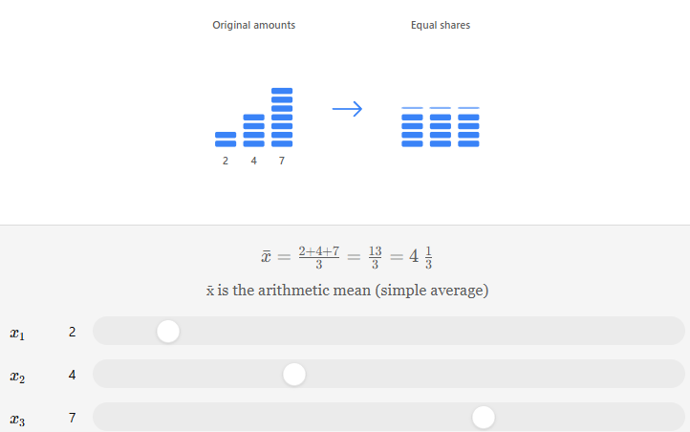
Errors: 2, 3, 3, 4, 4, 5, 5, 6
Mean = Sum of Errors ÷ Number of Observations
= 32 ÷ 8
= 4.00
Step 2 – Population Variance
Mean = 4
Sum of squared deviations = 12
Variance = 12 ÷ 8
= 1.50

Step 3 – Population Standard Deviation
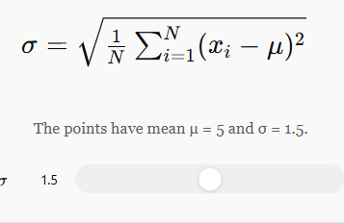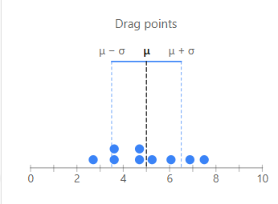
Standard Deviation = √1.50 ≈ 1.22

Part B – Model B
Step 1 – Mean
Errors: 1, 1, 2, 4, 5, 7, 8, 9
Mean = 37 ÷ 8
= 4.625
Step 2 – Population Variance
Mean = 4.625
Sum of squared deviations = 69.875
Variance = 69.875 ÷ 8
= 8.734
Step 3 – Population Standard Deviation
Standard Deviation = √8.734 ≈ 2.96
Comparison of Models
Measure | Model A | Model B
Mean Error | 4.00 | 4.625
Population Variance | 1.50 | 8.734
Population Standard Deviation | 1.22 | 2.96

Which Model is More Consistent?
Model A is more consistent because it has a much lower variance (1.50) and standard deviation (1.22) than Model B. Its prediction errors remain closer to the average, making its performance more reliable.
Is a Lower Mean Error Always Better?
No. A lower mean error alone does not guarantee a better model. A good machine learning model should have:
- Low mean error
- Low variance
- Low standard deviation
- Consistent performance
Therefore, model evaluation should consider multiple statistical measures rather than only the mean error.
Final Results
Measure | Result
Mean Error (Model A) | 4.00
Mean Error (Model B) | 4.625
Population Variance (Model A) | 1.50
Population Variance (Model B) | 8.734
Population Standard Deviation (Model A) | 1.22
Population Standard Deviation (Model B) | 2.96
More Consistent Model | Model A
Is lower mean error always better? | No, consistency and other evaluation metrics should also be considered.

OVERALL RESULTS AND FINDINGS

Case Study | Dataset | Key Results | Final Finding
Case Study 1 – Employee Salaries | 4, 5, 5, 6, 7, 8, 8, 9, 30 | Mean = 9.11, Median = 7, Mode = 5 & 8, Range = 26, Variance = 56.99, Standard Deviation = 7.55, Outlier = 30 | The salary ₹30 lakhs is an outlier that increases the mean. The median (₹7 lakhs) is the best measure of the typical employee salary because it is not affected by the outlier.
Case Study 2 – Website Response Time | 120, 125, 128, 130, 132, 135, 140, 145, 150, 300 | Mean = 150.5 ms, Median = 133.5 ms, Range = 180 ms, Variance = 2558.15, Standard Deviation = 50.58 ms, Skewness = Right-Skewed | The 300 ms response time is an outlier that makes the distribution right-skewed. The median better represents the normal website response time.
Case Study 3 – Student Performance | 42, 45, 48, 50, 52, 52, 55, 58, 60, 62, 65, 95 | Q1 = 49, Q2 = 53.5, Q3 = 61, IQR = 12, Outlier = 95, Mean = 57, Median = 53.5 | The mark 95 is an outlier identified using the 1.5 × IQR rule. It increases the mean, while the median remains a better measure of typical student performance.
Case Study 4 – E-Commerce Orders | 18, 20, 22, 22, 24, 25, 26, 28, 30, 35 | Mean = 25, Median = 24.5, Mode = 22, Variance = 22.8, Standard Deviation = 4.77, Coefficient of Variation = 19.08% | The online store receives 25 orders per day on average. The moderate standard deviation and coefficient of variation indicate stable and moderately variable customer demand.
Case Study 5 – Comparing Two Data Science Models | Model A: 2, 3, 3, 4, 4, 5, 5, 6 Model B: 1, 1, 2, 4, 5, 7, 8, 9 | Model A: Mean = 4.00, Variance = 1.50, SD = 1.22. Model B: Mean = 4.625, Variance = 8.734, SD = 2.96 | Model A provides more consistent predictions because it has the lowest variance and standard deviation. A lower mean error alone is not sufficient to determine the best model.

